CS 215 Intermediate C++ Programming

Noelie Vias

Professor Jeffrey Sanford

April 13, 2021

Contents

**Unit 1:Text Manipulation and Output Formatting** 3

**Program Execution** 3

**Unit 2:File Input/Output** 4

**Program Execution** 4

# **Unit 1:Text Manipulation and Output Formatting**

## **Program Execution**

Build and compilation success. Entered first name, last name and gpas of ten students. Then changed first letter of last and first name to caps and displayed the info in a proper format using columns separated for name of student and gpa.

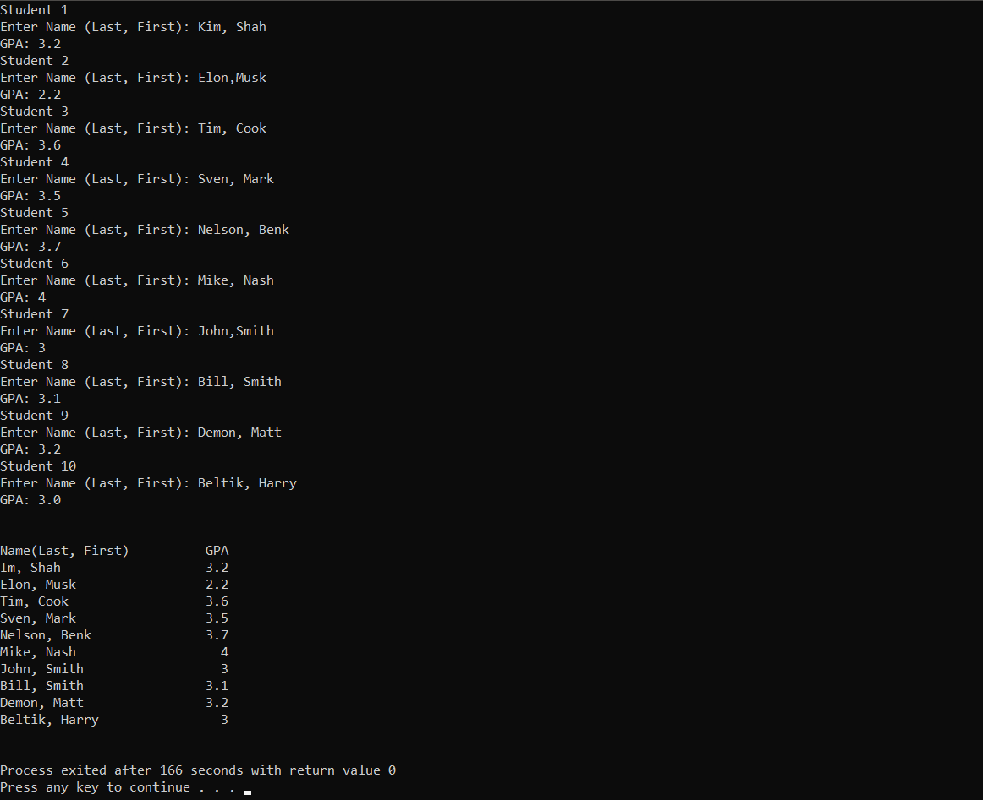

# **Unit 2:File Input/Output**

## **Program Execution**

Build and compilation success. The program understands the file format and successfully reads it. Stores the data in classes according to the given UML design. A test run for the output of questions and options looks like this.

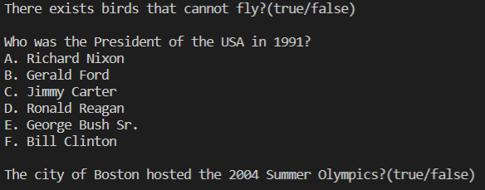

# Unit 3:File Input/Output

## **Program Execution**

Takes input from users and store them as in instance of class in an array container. After all the questions are added, writes them to aa file.

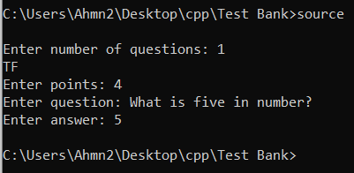

The generated out file.

